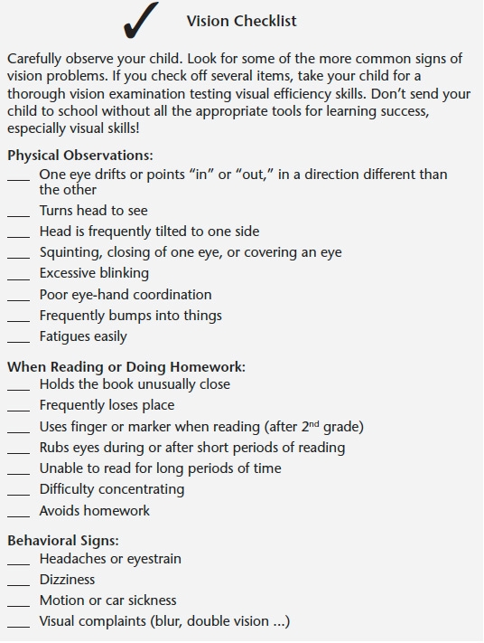
© 2010 HiClear Publishing, LLC & Dr. Lynn Hellerstein
www.LynnHellerstein.com www.HBVision.net 303-850-9499

Ask your optometrist 2 questions:
Do you do near point testing?
Do you provide vision therapy or refer to an Optometrist who does?
COVD.org – find a doctor

