Sports Vision Warmup Exercises
(Adapted from: 50 Tips to Improve Your Sports Performance
by Dr. Lynn Hellerstein)
1. Eye Calisthenics -*Note: practice deep breathing throughout with a relaxed body posture, always be aware of periphery

A. Wide Eye Pursuits: Follow an object in large circles, figure 8’s, horizontally, vertically, diagonally, and from far to near. Object movement should be smooth and continuous. Pay close attention to jerkiness or jumps from the player’s eyes

B. 2 Object Jump: Use 2 different objects roughly 6 inches apart. Call out the name of the object for the patient to look at. The patient should not “jump” to the other object until instructed to do so. You may vary horizontal distance slightly as player progresses with accurate jumps
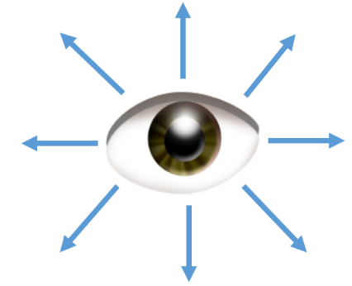
C. Wide Eye Stretches (pg. 9): Player should follow a target to “stretch” their eyes in 8 different gazes. Hold stretch to the count of 5 and come back to the center for a count of 3 before moving to the next gaze. Breathe out on stretch

2. Brock String

A. Bead Jump (pgs. 14-15): Space beads apart evenly throughout the whole length of the string. “Jump” eyes from bead to bead and notice the X at each bead. Hold for 3-5 seconds and moves eyes either up or down the string to ensure X is crossing on the bead and that both strings are always visible
B. Moving X with Beads: Slowly and smoothly slide eyes up and down the string so that it appears the X is moving up and down the string from bead to bead. Start beads within a few inches to one foot of each other. The further apart the beads are the more challenging it will be

B. Moving X with no Beads: No beads are to be used. Slowly and smoothly slide eyes up and down the string so that it appears the X is moving up and down the string. It should take 10 seconds to slide eyes up the entire string and 10 seconds to slide eyes down the entire string

3. Peripheral Charts for Soft Focus (pg. 18)

*always keep fixation on the center X, practice breathing and relaxing, this should not be straining. Start with chart roughly two feet away, moving chart closer increases difficulty

A. Direct Recognition: Have coach or another player touch a target for you to recognize

B. Scanning Recognition: Have coach or another player state a target out loud for you to scan for in your periphery to recognize

